Note: This document is “view only”. Please create a copy of this document and save it to your drive.

**SOP- Business Page Facebook Chat- Systems Vault**

**PREREQUISITE**

Manychat

SN Template (Email)- FAQ General Client Care Replies

Sarah Noked OBM Facebook Page Message Inbox

[Master: SOP- Client Care- Systems Vault](https://docs.google.com/document/u/0/d/1Z4sj_avVyYRnrrNoJP47GlVQT21g6zG0NKQUVAiAkmY/edit)

SN Template (FB Chat/Group)- General Questions Canned Responses

[Teamwork PM](http://sarahnoked.com/teamwork)

**PURPOSE**

To manage client inquiries on the FB page in an appropriate and timely manner, properly tag leads for follow up.

**POLICY**

There are weekly recurring tasks in [Teamwork PM](http://sarahnoked.com/teamwork) for managing the FB Business Page Chat

Checking the Facebook Page message inbox is a daily task, a part of managing the business’ social media accounts. It is imperative that we reply to chat enquiries as fast and as efficient as we can. The way we handle customer care will have an impact on how the business is being projected. Additionally, customer chat inquiries can be a lead source hence it is important that we know how to segregate leads from normal inquiries and what to do with them so that leads can turn into customers.

When replying to client inquiries, it’s important to mention who is replying to the follow up so as not to confuse clients

For example:

“Hi Steph.  
Charmaine here.

Thanks so much for your message.”

We have Chat automations set up with ManyChat:

1. When anyone communicates with our chatbot they get the following reply: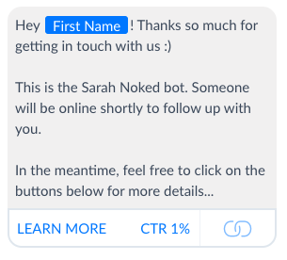

When contacting us through OBM Certification sales page of ref URL:

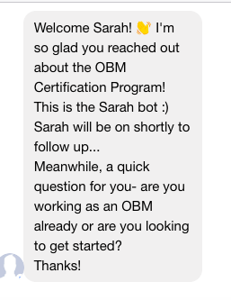

When contacting us through TGF sales page of ref URL:

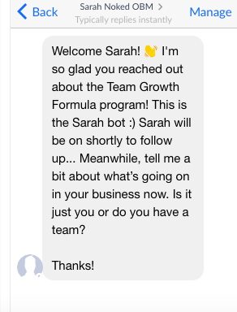

1. When people engage with our chatbot (ie send a message to our fb page), they get the following message: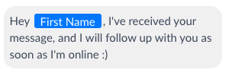

**PARTY**

Virtual Assistant

**PROPERTY**

Online Business Manager

**PROCESS**

Part 1: Follow up on all conversations- new and open

Part 2: Check the "Message Requests" Folder in Sarah Noked FB Personal Chat

Part 3: Label messages appropriately

Part 4: Notify Sarah for possible sales leads

Part 5: Unsubscribing spammy chats and blocking spammy people

**PROCEDURE**

**Part 1: Follow up on all conversations- new and open**

1. Go to [Sarah Noked OBM Facebook Page Message Inbox](https://www.facebook.com/sarahnoked/inbox)

2. Check the most recent messages that we received.

3. Check when the last message was received:

3.1 Was the last message sent by the client?

* If YES, assess if the message needs additional replies
* If NO, click the check mark symbol for “Move to Done”

3.2 Was the last message sent by us?:

* If YES, assess if it needs additional follow up (ex. Sales leads)
* If NO, click the check mark symbol for “Move to Done”

**Part 2: Check the "Message Requests" Folder in Sarah Noked FB Personal Chat**

1. In Facebook messenger, click the three small dots then “Message Requests”

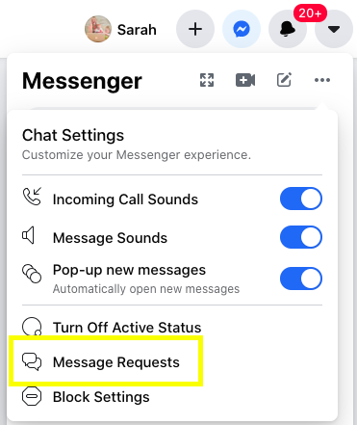

1. Check for messages hidden in the message requests folder. If you reply to a message in this folder, then it will automatically move to the Inbox.

**Part 3: Label messages appropriately**

1. Label the message according to what the message is about, apart from messages who does not require tagging like general messages.
   1. For messages asking about OBM Cert or you feel like it could be an OBM Cert lead, tag “OBM Cert Lead”
   2. For messages asking about Accelerator or you feel like it could be an Accelerator lead, tag “Accelerator Lead”
   3. For messages asking about TGF or you feel like it could be an TGF lead, tag “TGF Lead”
   4. For messages asking about SSC you feel like it could be an SSC lead, tag “SSC Lead”
   5. For technical issues, tag the contact “Technical Issue”

**Part 4: Notify Sarah for Sales Leads**

If a chat is a Hot Lead (possible product sale), reply to their inquiry to the best of your ability and if need be, notify Sarah as soon as possible. If the question is too specific, send the “For social media inquiries that are too business-specific or only Sarah can answer”message under [SN Template (FB Chat/Group)- General Questions Canned Responses](https://docs.google.com/document/d/1hAcD44D2q3Y3pjFec4ub4WYyu9QT4srmT4xjlJeZRfo/edit#) after pinging Sarah directly via TeamChat.

**Part 5: Unsubscribing spammy chats and blocking spammy people**

1. Observe the chat behavior and see if a certain thread is spammy or not.

1.1 Check their profile if they are posting “real” posts and not spammy or suspicious posts.

1.2 Check their photos and see if they are posting real photos and not just celebrity photos or other suspicious photos

2. If a user is determined to be spammy, click the three dots beside the profile picture on the right side of the screen > Ban From Page 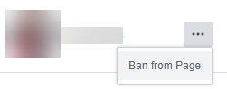

**Created by:**

**Department:** Operations & Support

**Date:**

**Revised:**

**Revised by:**